JOUR 4251
Psychology of Advertising 5.1 Attitudes (Cont.)
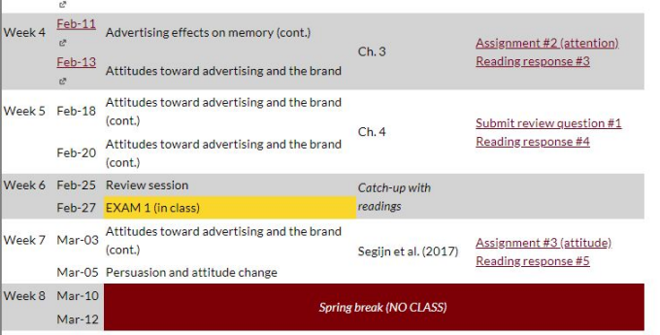
Recap Thursday
● What are attitudes?
○ Evaluative response
○ Directed to an attitude object
○ Derived from 3 classes of info: cognitive, affective, behavioral ● Self-perception theory
● Explicit versus implicit attitudes
○ And how to measure them
Why do people hold attitudes?
Attitudes will help consumers to separate good from bad. Decide whether to approach or avoid something.
Different functions can drive attitudes.
Understanding the purpose of a consumer’s attitude is an imperative step toward changing an attitude.
Function theory
Adjustment function
Maximize rewards and minimize penalties
Value-expressive function
Reflect values that are important to them or that they perceive as socially important to others
Ego-defensive function
Protect our self-esteem
Knowledge function
Need frames of reference for understanding the world; help us organize a chaotic world

● Adjustment function
● Value-expressive function
● Ego-defensive function
● Knowledge function

Assignment #3 - attitudes
For this assignment, you need to find two ads for the same product category (not necessarily the same brand) that are trying to appeal to two different functions.
In a report (double-spaced, approx. 500-750 words), respond to the following items:
1. Briefly describe the two advertisements you selected. Remember, they should be in the same product category, but they should appeal to different functions.
2. For each advertisement, briefly describe which functions (one for each) you think each ad is appealing to and why.
3. Which functional appeal do you think is more effective in this product category. Why?
DEADLINE: March 5, 2:30 pm (before class starts)
Are attitudes stable or do they change?
‘Attitude strength’
The stability of attitudes
Four attributes of strong attitudes:
1. Strong attitudes have higher stability over time 2. Greater impact on behavior
3. Greater influence on information processing 4. Greater resistance to persuasion
Determinants of attitude strength
● Accessibility
● Importance
● Knowledge
● Certainty
● Ambivalence
Accessibility 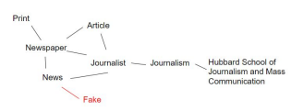
How easy or quickly an attitude can be retrieved from memory Node: activated easily
More accessible =
● Stronger influence on information processing ● Stronger influence on behavior
Example: Brand awareness
Measure through response time. Accessible takes less time.
Attitude importance
How important it is to you personally How concerned you are about it How relevant the attitude object is to you.
Attitude knowledge
How much information you have about the issue
Should be able to better evaluate the information presented
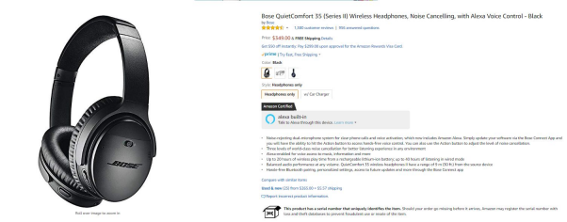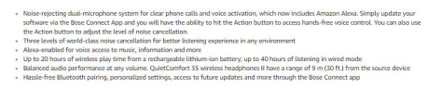
Attitude certainty
Confidence individuals have in the validity or correctness of their own attitude.
Ambivalence
State in which an individual gives an attitude object equivalently strong positive or negative evaluation.
In other words, we like and hate at the same time. You find yourself torn… Not the same as neutral!
Less predictive of behavior.
Ambivalence

How positive?
How negative?
How ambivalence could help persuasion
Easier to change through persuasion, but also evidence to the contrary.
1. If you have a two-sided argument and recipient must formulate opinion.
2. They will work harder to do so (effortful), elaborate more. 3. Elaboration (extended processing) is associated with high levels of persuasion
4. Thus, more elaboration more persuasion (see studies in book)
Determinants of attitude strength
In sum...
● Accessibility
● Importance
● Knowledge
● Certainty
● Ambivalence
What’s next?
● Continue reading Chapter 4 (attitudes)
○ Submit reading response by Feb 20 before class starts
● We will have a review session next week
○ Submit review question #1 by Feb 20 (Part of participant points) ○ About content of class - what needs additional explanation?
● Assignment #3 (attitude) due by March 5 before class starts

